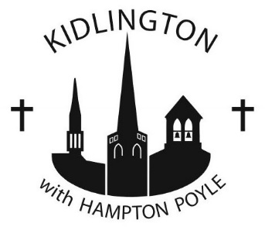

KIDLINGTON WITH HAMPTON POYLE PAROCHIAL CHURCH COUNCIL

St Mary’s Kidlington, St John’s Kidlington, St Mary’s Hampton Poyle

Under Government regulations all money given to the parish may benefit from a refund of tax provided you are identifiable and a taxpayer paying sufficient tax to cover the amount to be recovered on your cumulative giving (to the parish and to other charities). We can then obtain a refund of £2.50 for every £10.00 donated (at current tax rates). If this is applicable to you, please tick the box below, sign the declaration and return the completed form to Margaret Day (6 Winston Close, Kidlington, OX5 1BP; email: giving@kidhp.org.uk)

Gift Aid Declaration

Please treat as a Gift Aid donation the enclosed gift to Kidlington with Hampton Poyle Parochial Church Council to be used for KIDLINKS.

I am a UK taxpayer and understand that if I pay less Income Tax and/or Capital Gains Tax than the amount of Gift Aid claimed on all my donations in that tax year it is my responsibility to pay any difference.
Signed: …………………………………………… Date: …………………………………
Full Name: (Mr, Mrs, Miss.......................)
..............................................................................................
Address: .......................................................................................................
.......................................................................................................
Post Code: ..............................................

Note: If you pay Income Tax at the higher or additional rate and want to receive the additional tax relief due to you, you must include all your Gift Aid donations on your Self-Assessment tax return or ask HM Revenue & Customs to adjust your tax code. Gift Aid is reclaimed by the charity from the tax you pay for the current tax year.

contd….

By signing this form you are giving consent for the Parish of Kidlington with Hampton Poyle to hold your data for the purpose of reclaiming Gift Aid.

You can find out more about how we use your data from our “Data Privacy Notice” which is available from our website or from the Parish Office. You can withdraw or change your consent at any time by contacting the Parish Administrator at Parish Office, St John’s Church, Broadway, Kidlington, OX5 1DD, office@kidhp.org.uk, 01865-375611. Please note that all processing of your personal data will cease once you have withdrawn consent, other than where this is required by law, but this will not affect any personal data that has already been processed prior to this point

